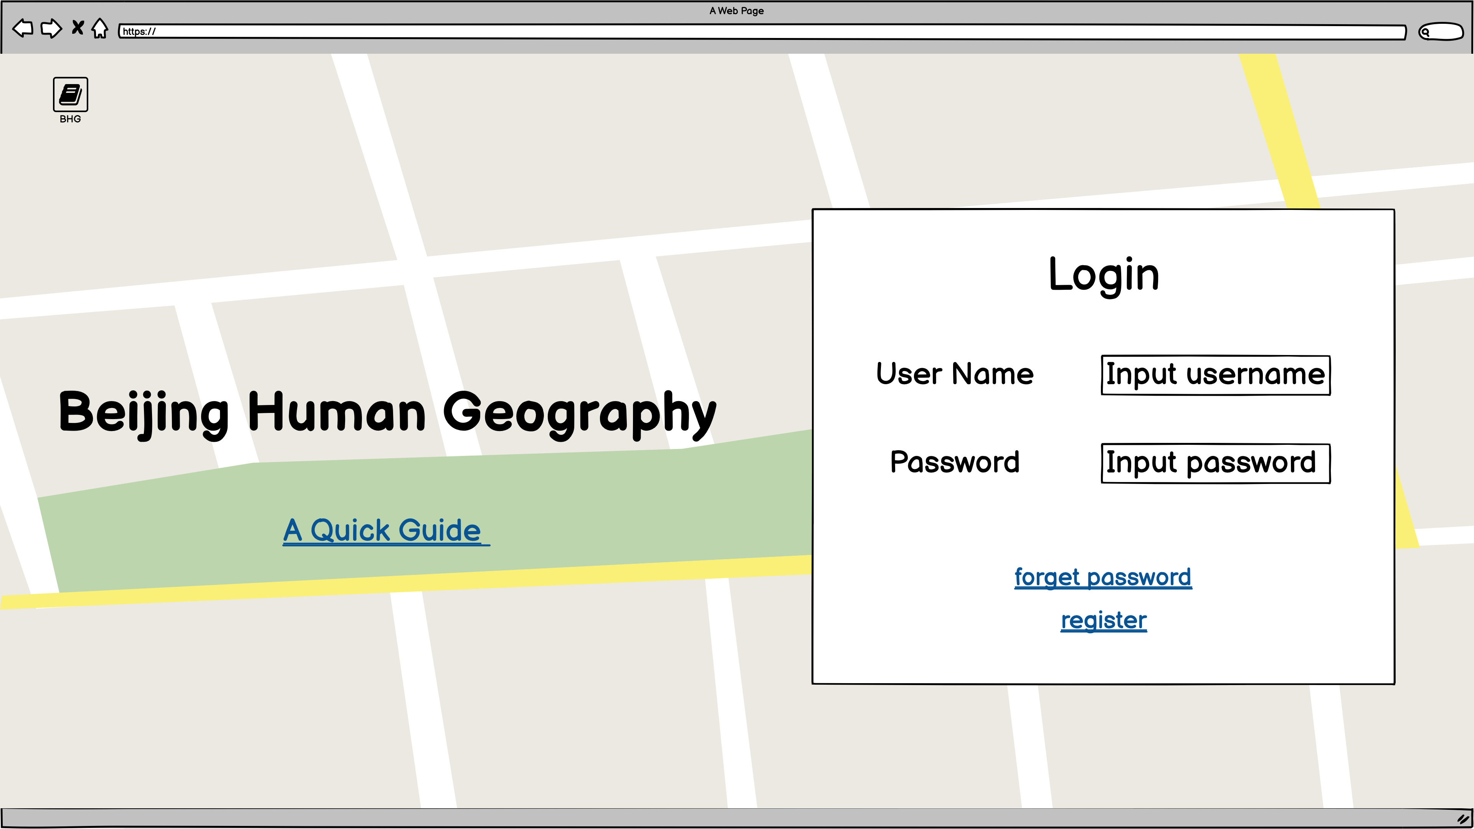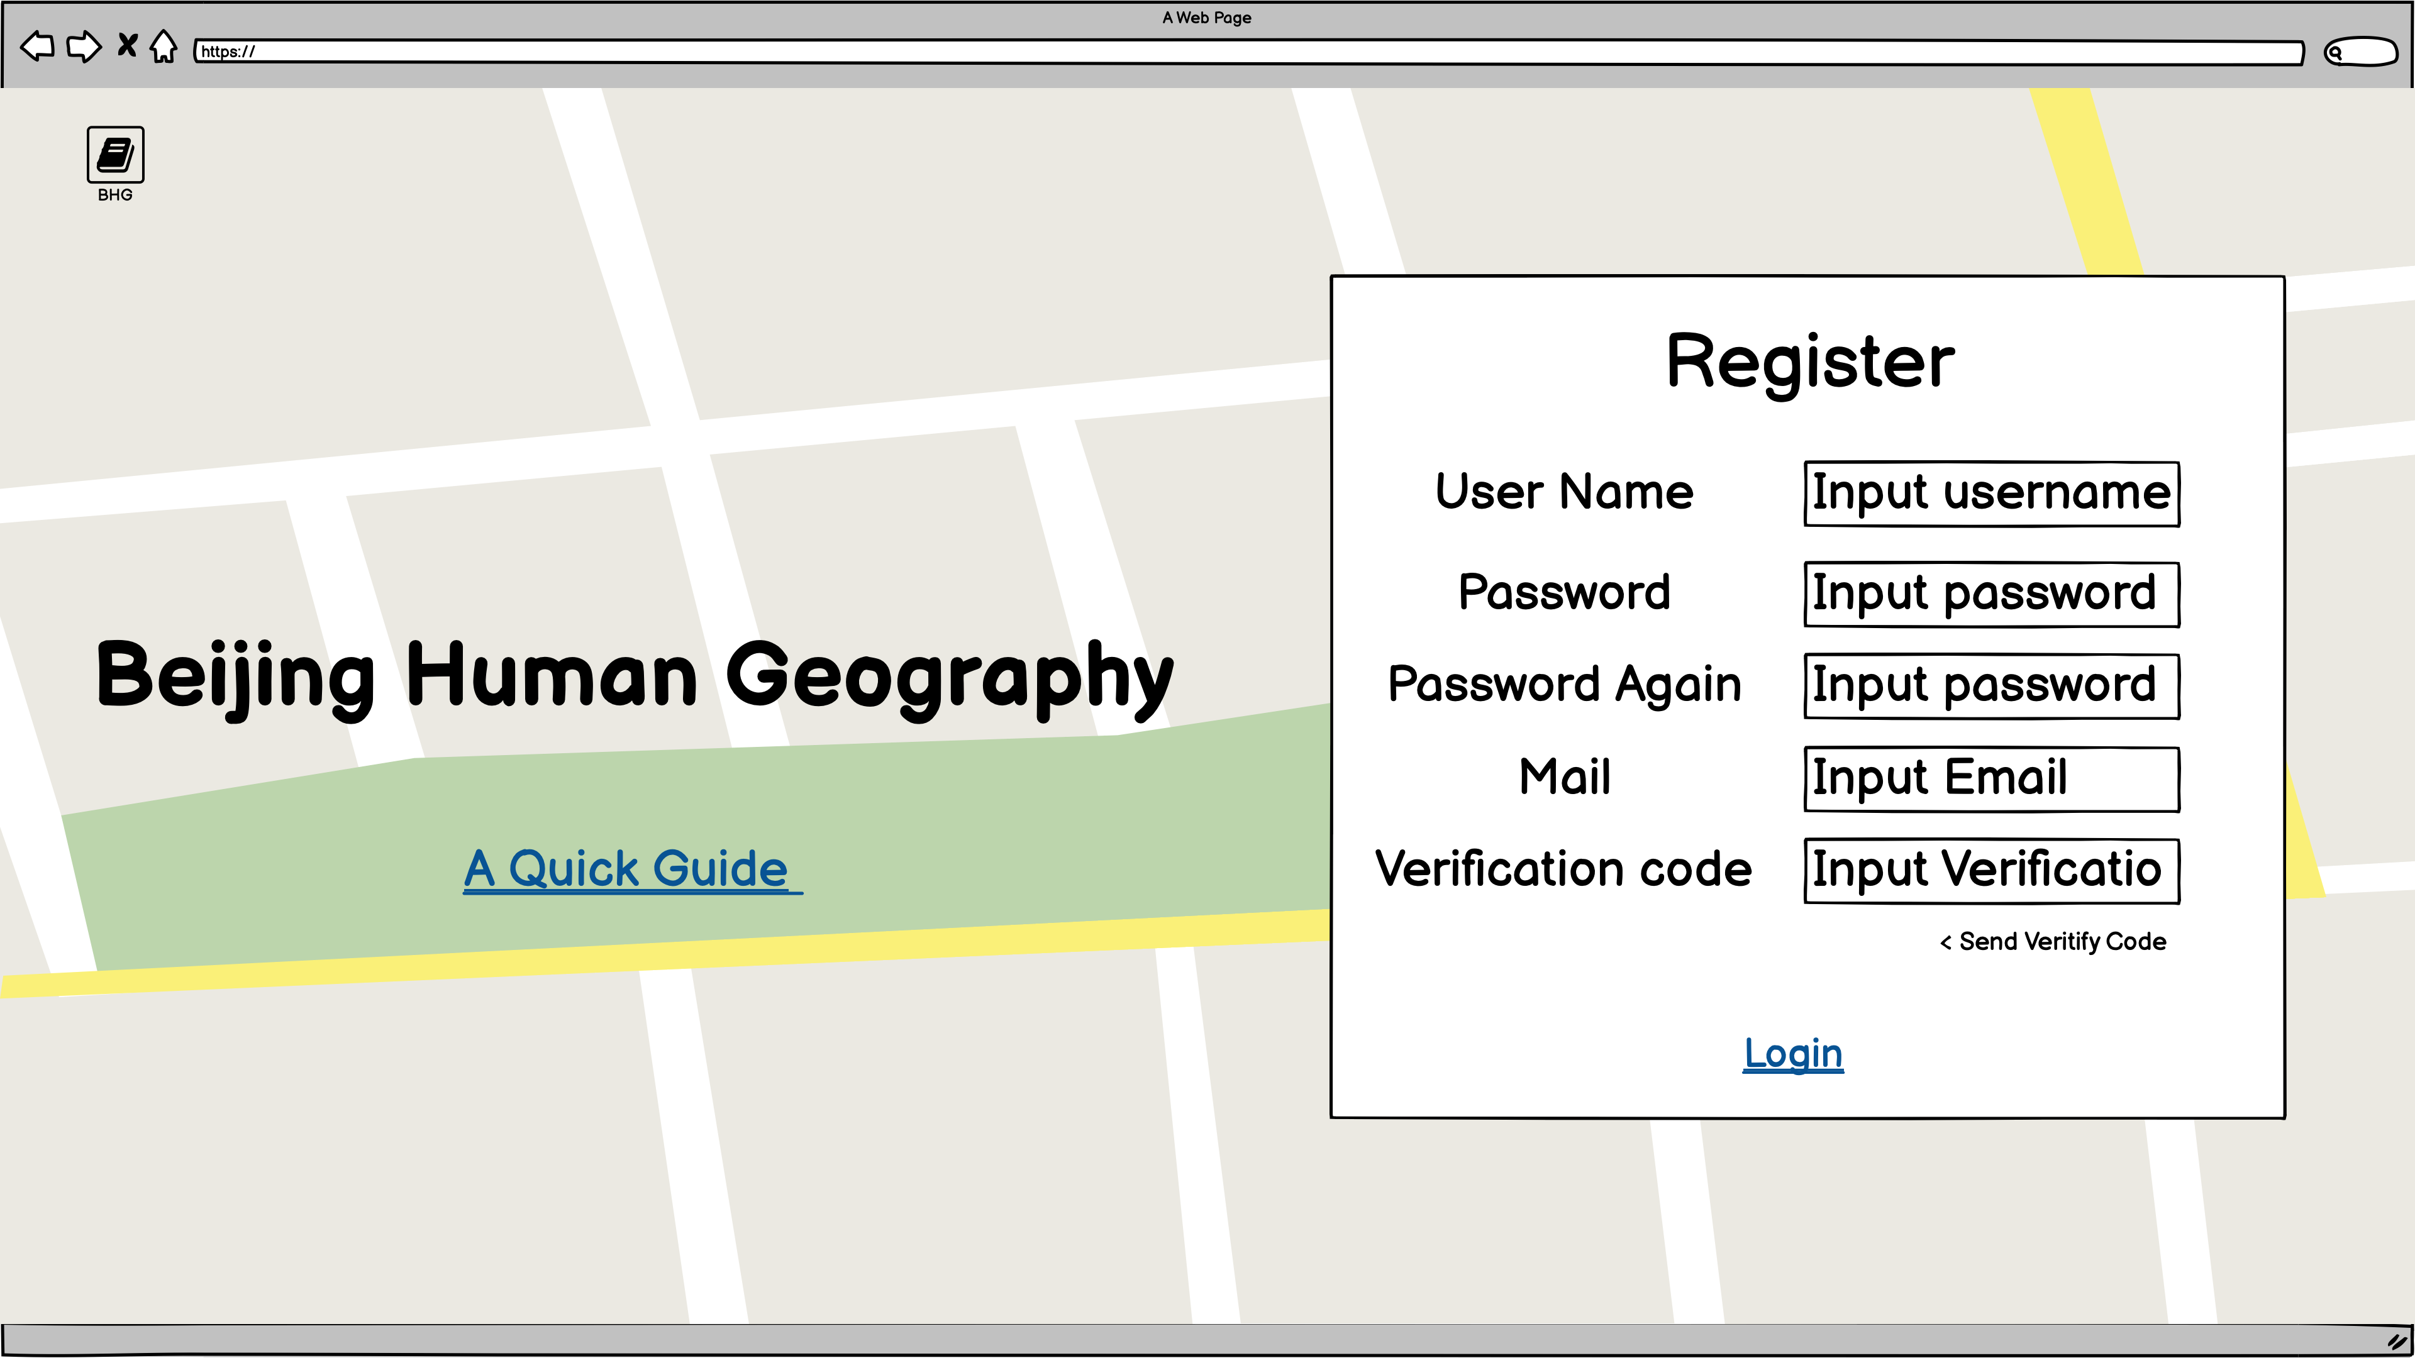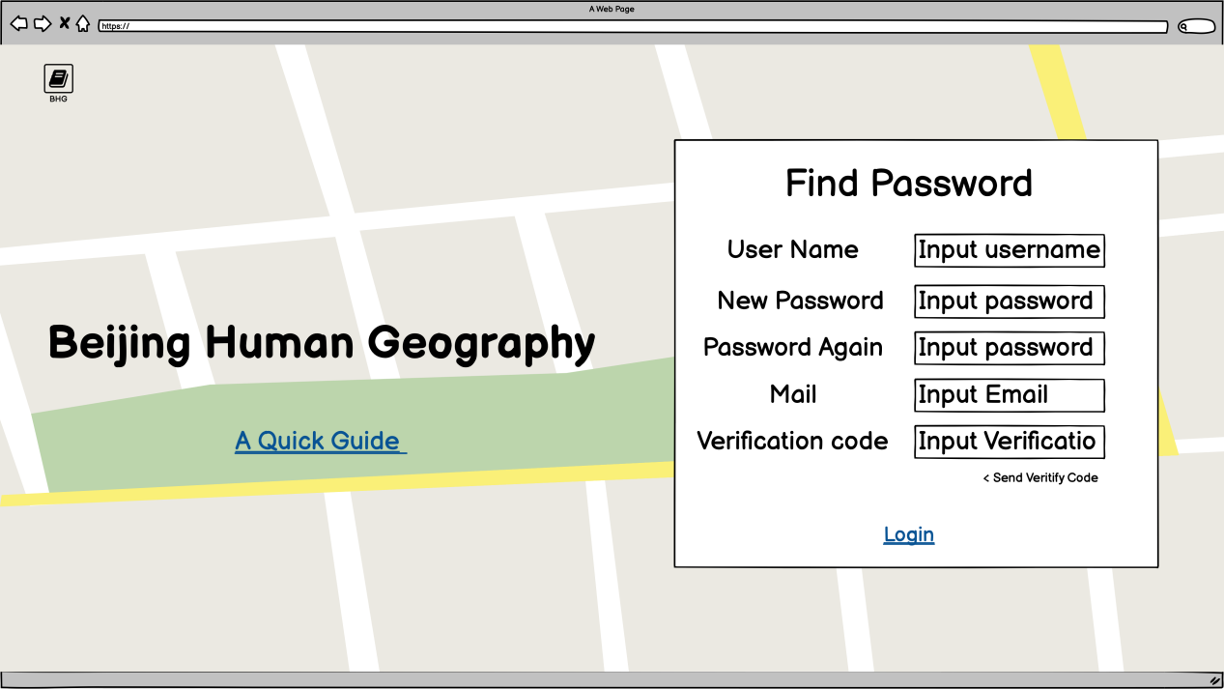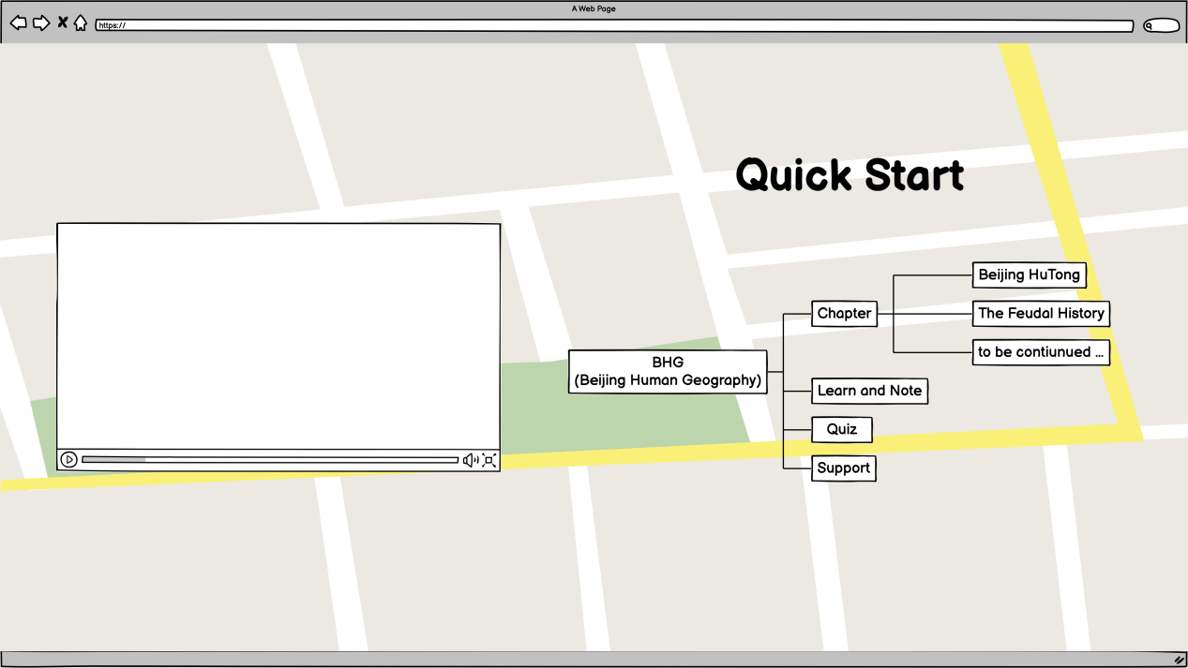

**Quick Start part is connected to Login and Register part! (Not a new page.)**

**Quick Start part is used to publicize the project and introduce it to people who don't know much about it. If user click the link “A Quick Guide”, there would be a within the page link happened.**